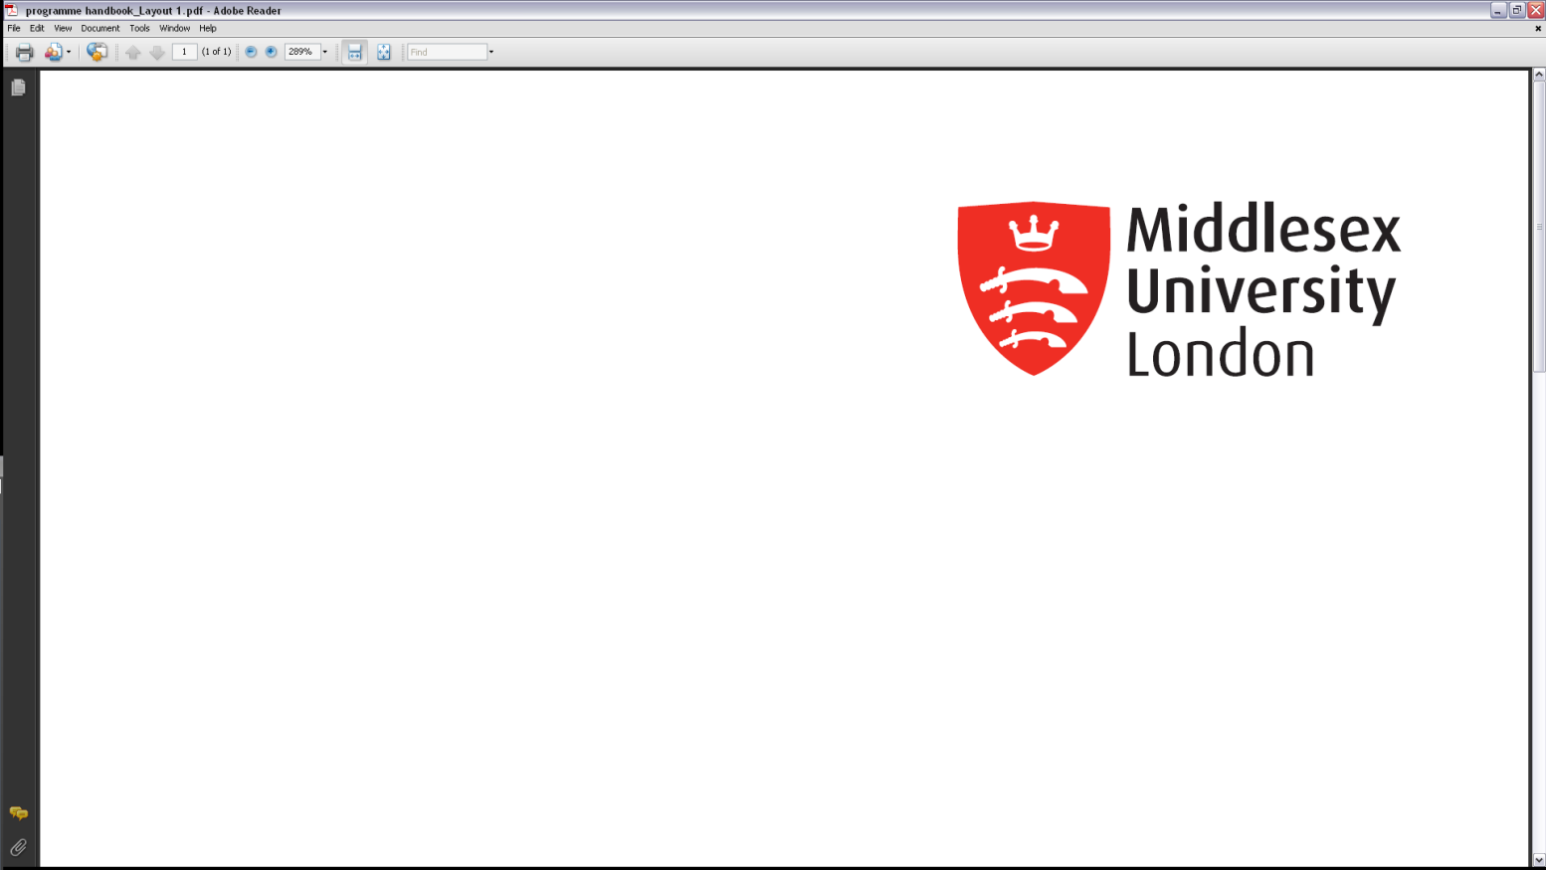
CST2310

Information Systems Analysis and Design

Final Individual Assessment
Submission: Friday 31st March 2023, 23:55hrs (End of Week 24)

Student ID:M00810926

Name: Abdullahi Mohamed

CAMPUS: HENDON

Question 1 Part 1

CLD of University Coursework System

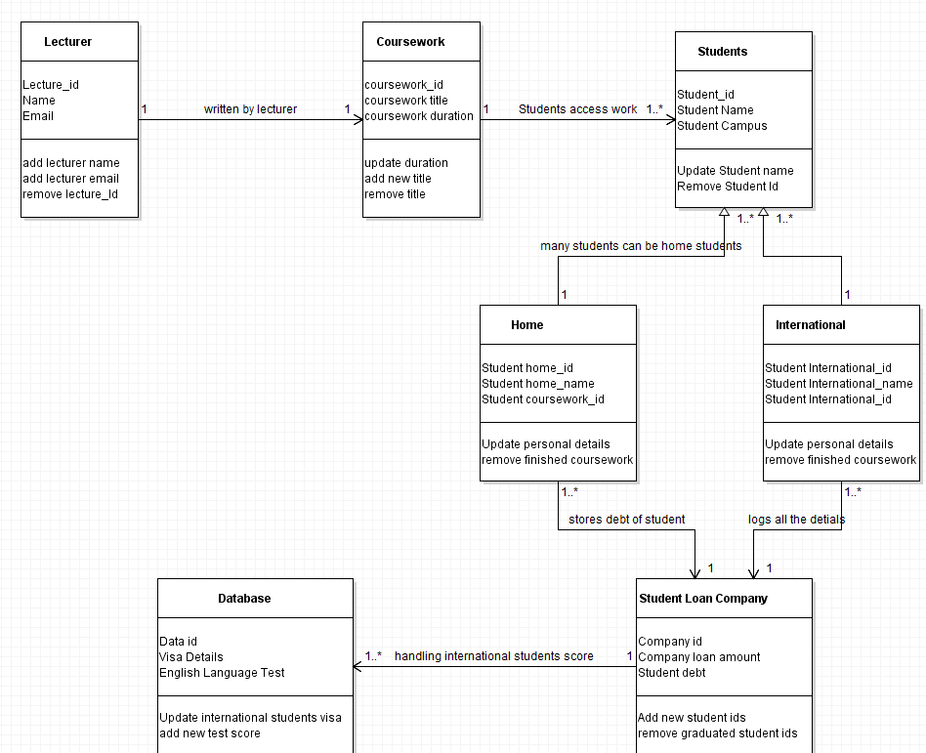

Question 1 Part B
Definition of Superclass, Subclass, Inheritance and Generalisation
Subclass is an open arrowhead that points to the parent class and superclass is the main element which controls the subclass. In a UML schematic model, a generalisation is when there is one model element usually referred as “the child” to which it based on the main element which is “the parent”. Inheritance is an important concept in an object-oriented analysis and design, can have a variety of levels. (Source Making,2023)
Example of Generalisation
Generalisation is the process of shared characteristics from two or more classes which is known as superclass. The example of a generalisation in my class diagram is the parent element is students to which I made an association relating to the case study as they are two types of student’s home and internationals. Meaning that the subclass and the child element are the home students and international students as they are based on the main element. (Dusan Rodina,2022)
References
Source Making(2023),Generalisation, Specialization and Inheritance, available from Modelling IT Systems at: https://sourcemaking.com/uml/modeling-it-systems/structural-view/generalization-specialization-and-inheritance# ![date accessed 24th March 2023]
Dusan Rodina (2022), Inheritance Class Diagram, available from Help tutorials UML diagramming at: https://www.softwareideas.net/inheritance-diagram ![date accessed 24th March 2023

Question 2 Activity Diagram for local supermarket

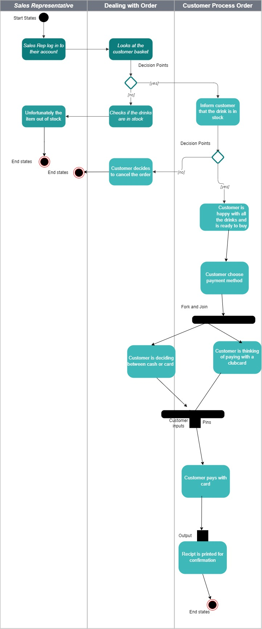

2b) The reason being that there is a directly correlation between use cases and activity diagram. The relationship is that an activity diagram is the flow of events for example in my diagram it is a workflow a sales representative processing customer order. (Rational Software Corporation,2001)
The flow of events in a use case describes what need to use in the system and that it provides value to an actor. Ultimately it documents a step-by-step process within a use case and shows the relationship between steps and represents alternative flows. The basic symbols in the activity diagram are used from use case. (Binus University, 2016)
References
Rational Software Corporation(2001) , Guidelines : Activity in the use case model available from https://sceweb.uhcl.edu/helm/RationalUnifiedProcess/process/modguide/md_actd.htm ![date accessed 24th March 2023]
Binus University(2016), Activity for the use case, available from school of information system at: https://sis.binus.ac.id/2016/12/13/activity-diagram-for-use-case/ ![date accessed 24th March 2023]

Question 3-Sequence Diagram

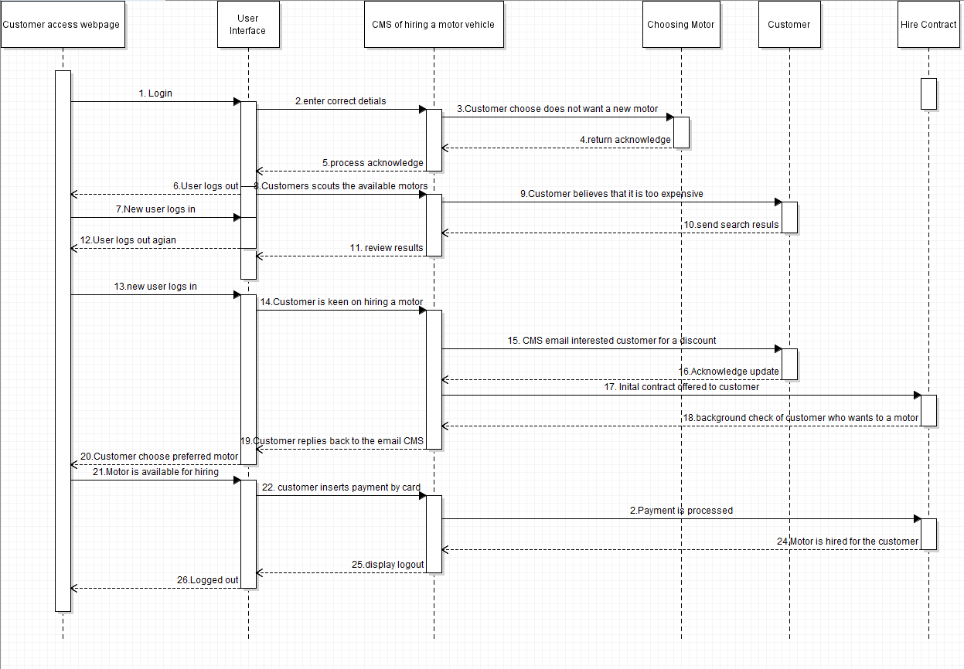
3b) Sequence diagram shows the objects interacting with one another by using lifelines and activation bars. Focusing on those helps perform a function and ends the lifeline and is a modelling solution in UML. (Sparx Systems,2023)

The difference between static and dynamic UML diagrams is that a static diagram is not a runtime model whilst a dynamic model refers to a runtime model. Another differences between the two is that dynamic model keeps changing within time whereas static model is equilibrium of a ready state. Static modelling has a more structural approach rather than behavioural and dynamic is representation of the behaviour of the system. (DifferenceBetween.com,2023)

References
Sparx Systems (2023), The dynamic model. Available from enterprise architect at: https://sparxsystems.com/resources/tutorials/uml/dynamic-model.html ![date accessed 24th March 2023]
DifferenceBetween.com(2023), Difference between static and dynamic modelling, available from Olivia at https://www.differencebetween.com/difference-between-static-and-vs-dynamic-modelling/ ![date accessed 24th March 2023]

Question 4 - Part A
I will be identifying the key principles from GDPR relating to security measures. The first principle I will mention is the lawfulness, fairness, and transparency, this is when data is processed lawfully and in a manner catering to the individual. This can be used against TalkTalk as there were not catering to the individual’s personal data. The article 5 states the accurate and necessary information only is kept and is always up to date, always rectify the current data. TalkTalk could have kept only necessary information of the 157,000 customers to which id the personal details where accessed it would have been only minimal information. The third key principles are data is processed in a manner that guarantees customers security against their personal data using technical measures. TalkTalk deliberately failed to comply with this data protection principle that would have help keep their database secure. The final key principle from GDPR that I will display is the data minimisation method, which is where only adequate, relevant and limited are processed into the system. (Ico,2023)
References
Ico (2023), the principles available from information commissioner’s office at https://ico.org.uk/for-organisations/guide-to-data-protection/ ![date accessed Friday 24th March 2023]
Question 4 – Part B
This question below I will be explain 3 duties that are placed on data controllers and system design.
Rights on data erasure
The duties being in place is responsibilities and consideration processing each individual data and minimise the risks by backing up their work.
The data/controllers are ensured to be protected to which is known as the “right to be forgotten”, this is when the customer has the right to have their data erased by the data controller. There are many instances to which the customer can get their data erased, another being that when the data has been unlawfully processed from something unnecessary. The last example is data can be erased when used without your consent to any part of the process. (DPC,2023)
System/designs
Data is protected through solutions, it is relying on technologies such as data loss prevention, storage with built in data protection such as firewalls can help erase data. (Cloudian,2023)

References
Data Protection Commission(2023), the right to erasure (GDPR) available at your data from https://www.dataprotection.ie/en/individuals/know-your-rights/right-erasure-articles ![date accessed Friday March 24th 2023]
Cloudian (2023) Data protection and privacy, available from solutions at: https://cloudian.com/guides/data-protection/data-protection-and-privacy-7-ways-to-protect-user-data ![date accessed Friday March 24th 2023]
Breach notifications
Data/controllers
It can only process the personal data from the controller instruction, this required by law. To which you cannot step outside because being a process means that you can become a controller. Being aware of personal breaches, you must notify the controller instantly. (Ico,2023)
References
Ico (2023), What does it mean if you’re a processor?, available from https://ico.org.uk/for-organisations/guide-to-data-protection/guide-to-the-general-data-protection-regulation-gdpr/controllers-and-processors/what-does-it-mean-if-you-are-a-processor/ ![date accessed Friday March 24th 2023]
System/designs
Their several breach detector systems to which I will be listing down a few.
Breach sight: cloud based and great a scanning notification. (Comparitech,2023)
Trend Micro Deep Discovery Detector: this is a highly rated threat protection device and includes software event tracking. (Comparitech,2023)
Spy Cloud: Lock down system user accounts. (Comparitech,2023)
Insider Security: A Singapore based threat protection minor, available from the cloud or for on premises installation. (Comparitech,2023)
References
Comparitech(2023),10 best breach detection systems for 2023,available from breach system at: https://www.comparitech.com/net-admin/best-breach-detection-systems/ ![date accessed Friday 24th March 2023]

Matter of Consent
Data/controllers
Regularly review the relationship of the customer to which if it has not change you can keep personal data. A record is kept of when and how we got consent of the individual, when new individual data is kept, we use clear and plain language to use therefore the individual is aware of keeping personal information. (Ico,2023)
References
ICO(2023)Consent, available from for organisations at: https://ico.org.uk/for-organisations/guide-to-data-protection/guide-to-the-general-data-protection-regulation-gdpr/lawful-basis-for-processing/consent/ ![date accessed Friday 24th March 2023]
System/designs
Companies require the consent of customer to process their data to which they must have a legitimate reason to withhold their details, to which down below I will be mentioning systems that can help with matter of consent.
SolarWinds: helps with compliance meaning that it is for protecting individuals. (Comparitech, 2023)
Perimeter: cloud-based security tools combine connection security and access rights managing the hybrid system. (Comparitech, 2023)
Logic Gate: A cloud based which is risk compliance that helps you keep within GDPR. (Comparitech, 2023)
References
Comparitech (2023), 11 Best GDPR compliance Software , available from administration expert at: https://www.comparitech.com/data-privacy-management/gdpr-compliance-software/ ![date accessed Friday 24th March 2023]
Question 4 – Part C
In this question below I will be explaining by4 different types of technologies and how they play their role in protecting information system for a business.
Physical security controls are when there is a building site for protection of equipment from being vandalised or stolen, for example CCTV cameras. They work to protect information system by limiting the access to spaces where data is stored. An example would be that pad locks to ensure the person who set the lock is aware, only if they choose to share this information someone else can access. The one technology that I will be further explaining is pad locks, this is because you can delay and retain physical assets to which it can protect vital information system. That being a said it can hold for example the registration and taxable income document to which only they can see it. This allows the business owner to be private with the documentation or any other personal belonging so that all employee is protected and the business itself. (Compass,2023)
Software security controls are an idea implemented to protect software against malicious attacks, it is a must to provide authentication. Examples are that firewalls, antivirus, and software for detecting the system. The purpose is to protect software programs from malicious threats such as malware or other viruses. This technology that I selected is Firewalls are digital system that has a definite set rules that is always followed, they aim to secure personal data safe and keeps unauthorized traffic and only communication that are deemed safe. It can protect information system in a business because it blocks access to unproven website or anything the owner does not approve. Also, it can control the usage of bandwidth meaning that it can configure the specific types of traffic of the internet. (CrowdStrike,2023)
Electronic security controls are digital networks that control access to portal, they also have a detective system to alert. An example could be that having two step authentication process to ensure all users are safely secured. They can protect information systems in many ways, which some being having to use a strong password, backing up your data and making your WI-FI being secure. The reason being a two-factor authentication is important is that it immediately minimising the risk of associated a customer detail together. For example, if two users had the same first name and surname, they two set verification can be sorted through their different phone number, that allows them to protect both customers equally. (Ico,2023)
Management security controls is when a piece of work is developed, and a maintenance of the system is undertaken, this can be whatever the business procedures require. The technology I chose is controlling policies is that it is a process as it helps your business to check any errors and put the right corrections in place and keeps your project management on track, this helps the business steadily progress to which because they are outlining what must be done to ensure of a well-rounded project. (NLST,2023)

References
Compass (2023), what is physical security? , available from IT compliance at https://www.compassitc.com/blog/cyber-physical-security-why-you-need-both![date accessed 29th Wednesday 2023
Pleco (2023), guide to security, available from table of contents at https://www.pelco.com/blog/physical-security-guide ![date accessed Wednesday 29th March 2023]
Crowd strike(2022),Software security definition and guidance available from cybersecurity at https://www.crowdstrike.com/cybersecurity-101/security-it-operations/software-security ![date accessed Wednesday 29th March 2023]
Ico(2023),11 practical ways to keep your system safe, available from organisation at https://ico.org.uk/for-organisations/sme-web-hub/whats-new/blogs/11-practical-ways-to-keep-your-it-systems-safe-and-secure/ ![date accessed Wednesday 29th March 2023]
NLST (2023), management controls, available from glossary at: https://csrc.nist.gov/glossary/term/management_controls ![date accessed Wednesday 29th March 2023]

